Project 8: Ultrasonic Following Smart Car
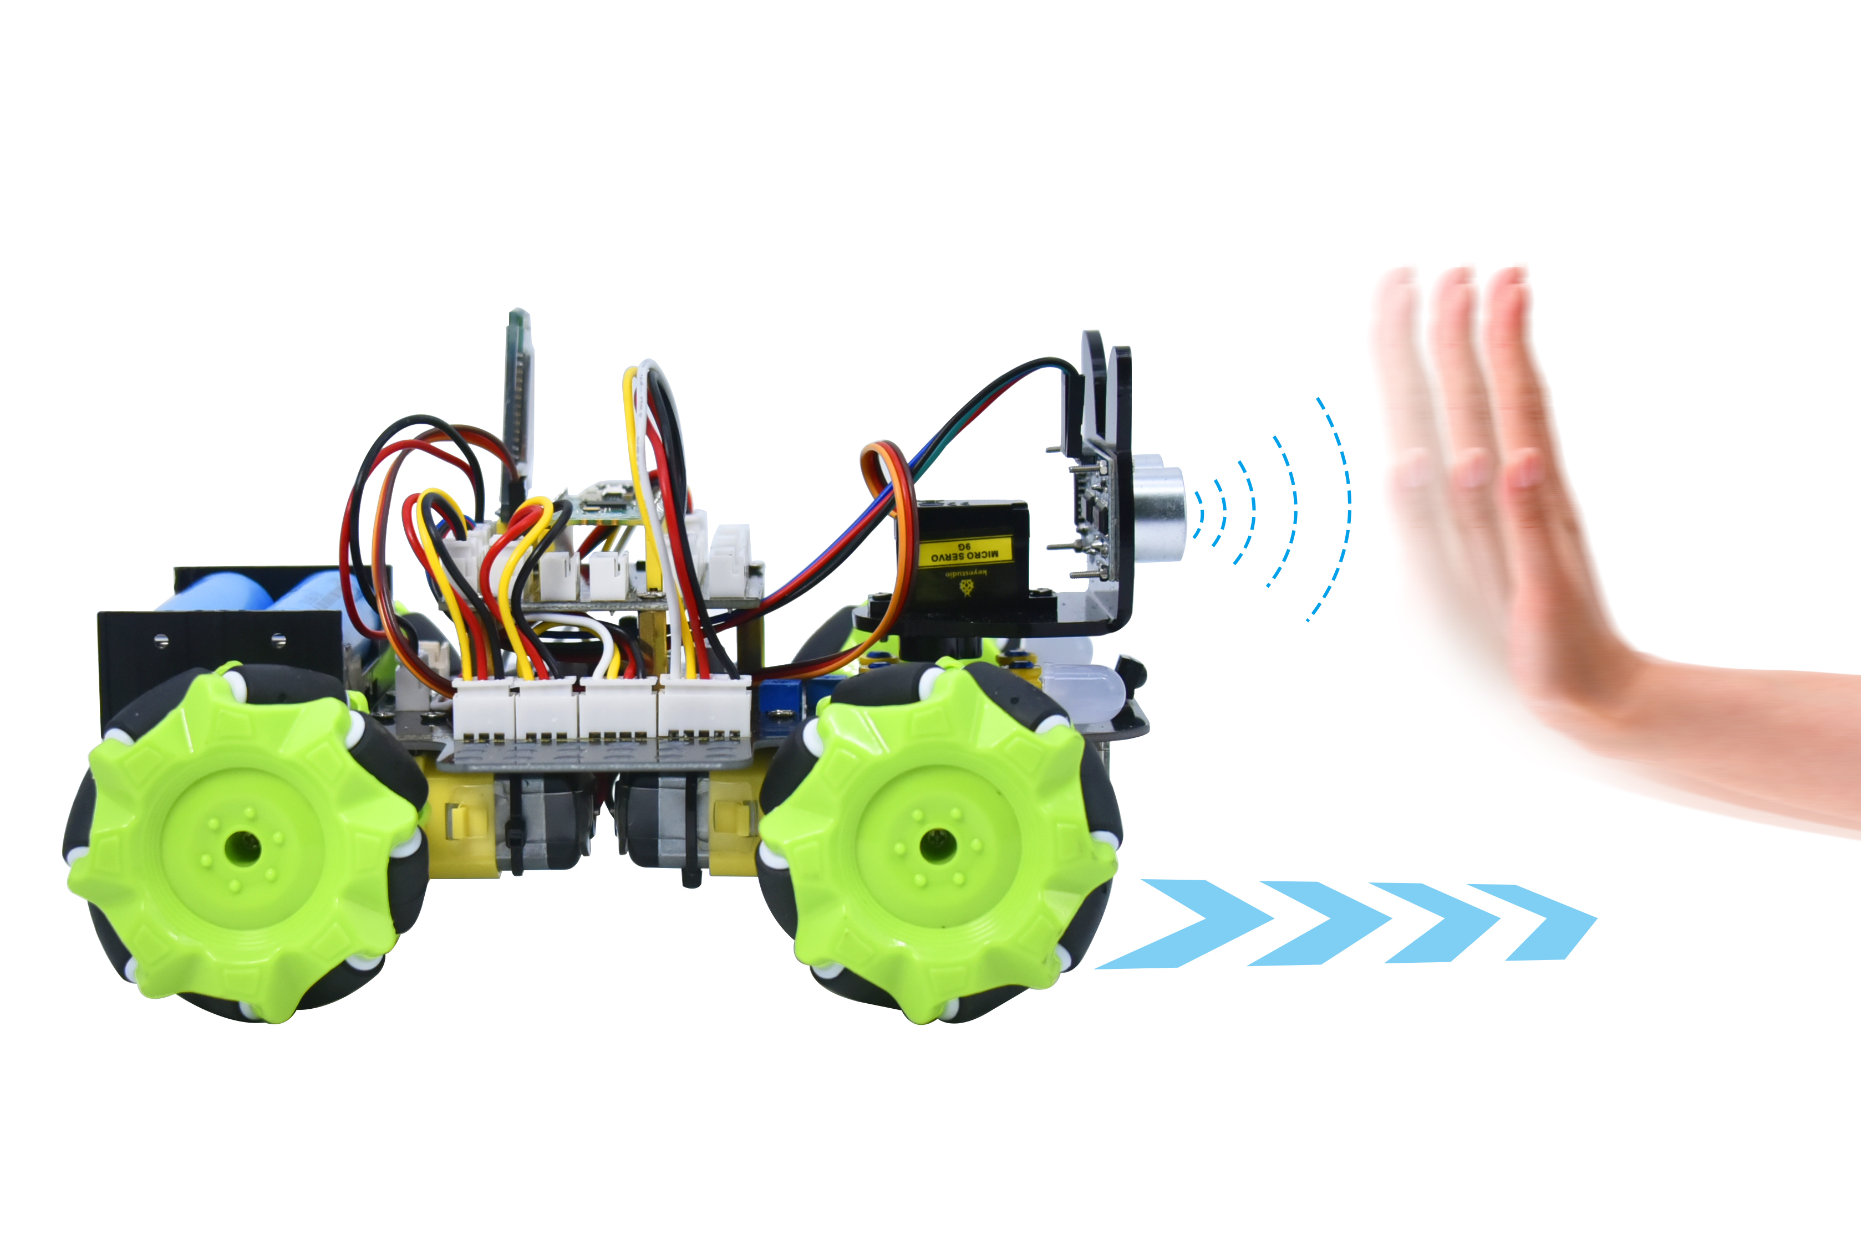

1. Description
In this project, we will work to combine an ultrasonic sensor with motors to make an automatic follow smart car.
The ultrasonic sensor detects the smart car and the obstacle distance to control the motion status of car.

- Flow Diagram
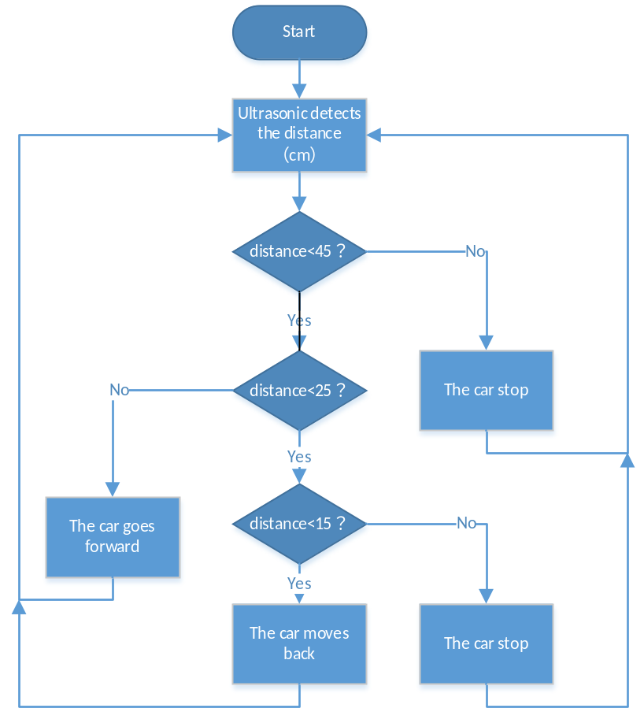

3. Test Code
/*
Keyestudio 4WD Mecanum Robot for Pico
lesson 8
Ultrasonic follow Robot
http://www.keyestudio.com
*/
#include "MecanumCar_v2.h"
#include "Servo.h"

mecanumCar mecanumCar(20, 21); //sda-->20,scl-->21
Servo myservo; //Define an instance of a servo

/*******Ultrasonic sensor interface*****/
#define EchoPin 4 //ECHO to GPIO4
#define TrigPin 3 //TRIG to GPIO3

void setup() {
pinMode(EchoPin, INPUT); //The ECHO pin is set to input mode
pinMode(TrigPin, OUTPUT); //The TRIG pin is set to output mode
myservo.attach(2); // attaches the servo on GPIO2 to the servo object
myservo.write(90); //Rotate to 90 degrees
mecanumCar.Init(); //Initialize the seven-color LED and the motor drive
}

void loop() {
int distance = get_distance(); //Get the distance and save in the distance variable
Serial.println(distance);
if (distance <= 15) //Receding range
{
mecanumCar.Back();
}
else if (distance <= 25) //Stop range
{
mecanumCar.Stop();
}
else if (distance <= 45) //Range of advance
{
mecanumCar.Advance();
}
else //Other cases stop
{
mecanumCar.Stop();
}
}

/*********************Ultrasonic detects the distance*******************************/
int get_distance(void) { //Ultrasonic detects the distance
int dis;
digitalWrite(TrigPin, LOW);
delayMicroseconds(2);
digitalWrite(TrigPin, HIGH); //Give the TRIG a high level of at least 10 µ s to trigger
delayMicroseconds(10);
digitalWrite(TrigPin, LOW);
dis = pulseIn(EchoPin, HIGH) / 58.2; //Work out the distance

delay(30);
return dis;
}

4.Test Result
After uploading the code successfully, turn on the switch and the car will follow in a straight line. We put the palm of our hand in front of the ultrasonic, slowly forward, the car will follow our palm to move.

5. Code Explanation

myservo.write(90); | Make the servo rotate to 90 degrees
int distance = get_distance(); | Define an integer variable to store the measured distance, and then control the car driving according to it
if (distance <= 15)  {  mecanumCar.Back();  } | When the front distance measured is less than 15cm, the car moves back
else if (distance <= 25)  {  mecanumCar.Stop();  } | Otherwise, the car will stop when the front distance is less than 25cm
else if (distance <= 45)  {  mecanumCar.Advance();  } | The car will go forward when the front distance is less than 45cm
else  {  mecanumCar.Stop();  } | The car will stop when the front distance is bigger than 45cm

